**SPRINT 2 DELIVERABLES**

# TEAM ID: PNT2022TMID24269

WORK DONE: **Dashboard with useful insights for further work with respect to predictive analysis for CROP PREDICTION**

**Tool used:** Cognos analytics by IBM **Link of work done:**

[**https://us1.ca.analytics.ibm.com/bi/?perspective=dashboard&pathRef=.my_folders%2 FSPRINT%2B2%2BDELIVERABLES%2BCROP%2BPREDICTION&action=view&mode= dashboard&subView=model00000184469edc1b_00000000**](https://us1.ca.analytics.ibm.com/bi/?perspective=dashboard&pathRef=.my_folders%2FSPRINT%2B2%2BDELIVERABLES%2BCROP%2BPREDICTION&action=view&mode=dashboard&subView=model00000184469edc1b_00000000)

**Insights:**

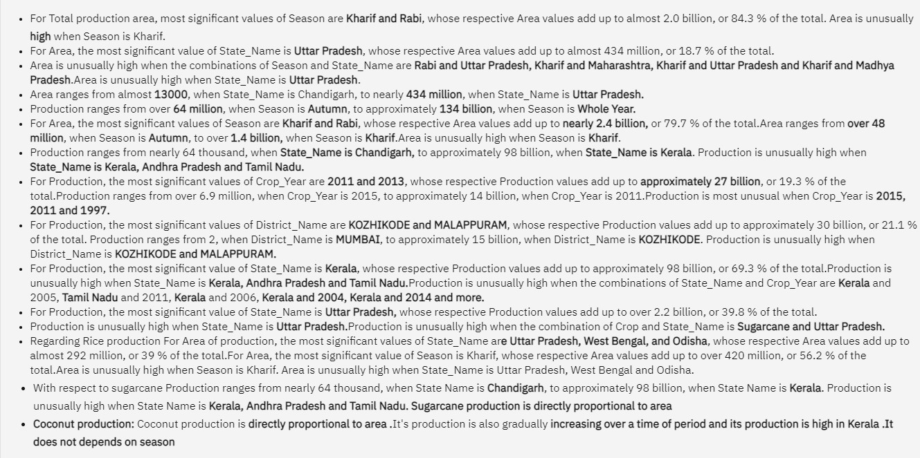

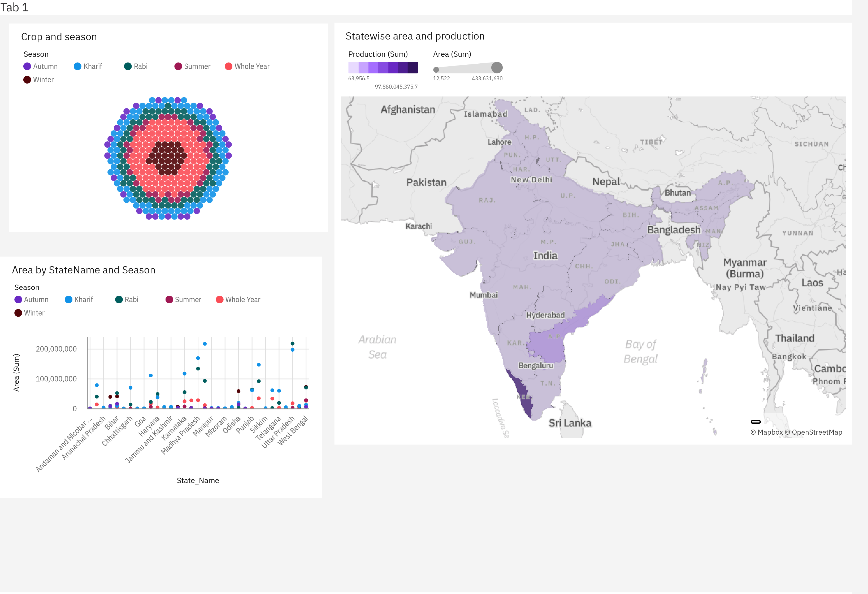

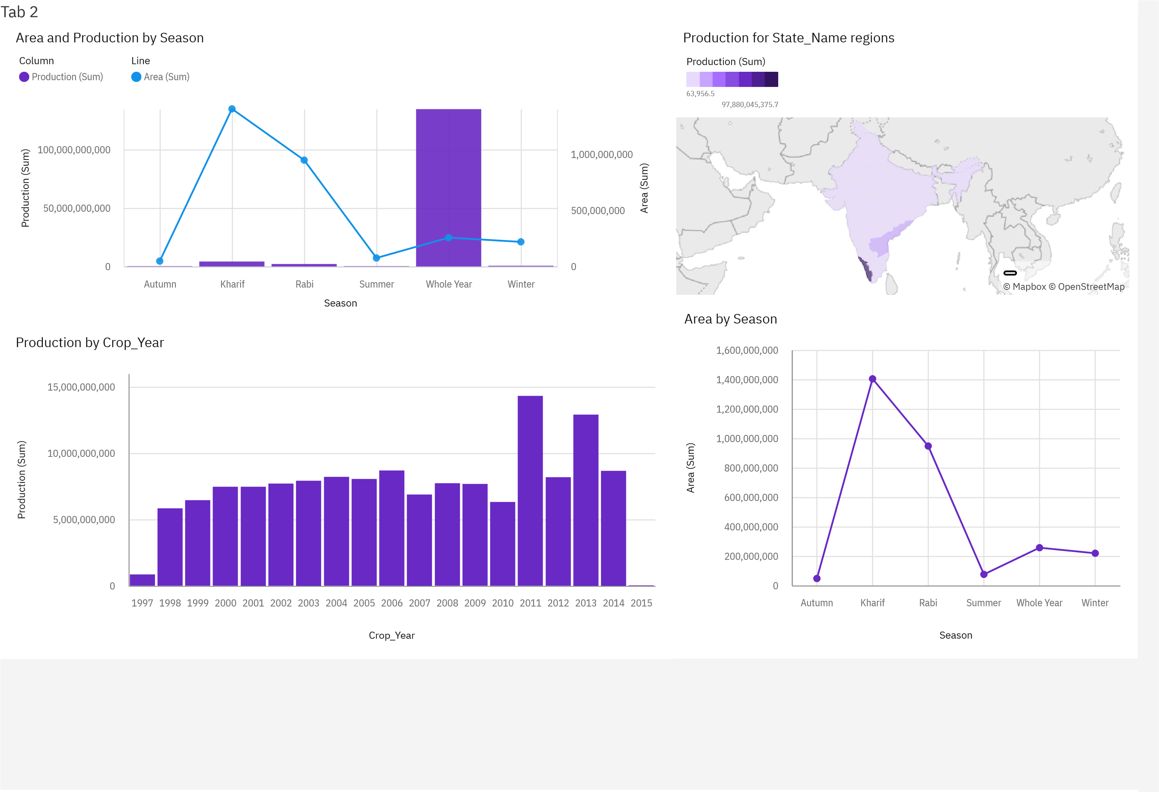

|  |  |  |
| --- | --- | --- |
| Tab 3 |  |  |
| District wise production  Production (Sum)  © Mapbo  [x](https://www.mapbox.com/about/maps/)    © OpenStreetMa  [p](https://www.openstreetmap.org/about/)  2  15,280,739,862.95 | Production by State_Name and Crop_Year  Production (Sum)  412 6,330,149,104  Crop_Year  1997 1998 1999 2000 2001 2002 2003 2004 2005 2006 2007 2008 2009 2010 2011 2012 2013 2014 2015  S  t  a  t  e  _  N  a  m  e |

|  |  |
| --- | --- |
| Tab 4 |  |
| SugarCane Production by State Production for State_Name regions  Sugarcane  Crop  Andaman and Nicoba...  Andhra Pradesh  Arunachal Pradesh  Assam  Bihar  Chhattisgarh  Dadra and Nagar Haveli  Goa  Gujarat  Haryana  Himachal Pradesh  Jammu and Kashmir  Jharkhand  Karnataka  Kerala  Madhya Pradesh  Maharashtra  Manipur  Meghalaya  Mizoram  Nagaland  Odisha  Puducherry  Punjab  Rajasthan  Tamil Nadu  Telangana  Tripura  Uttar Pradesh  Uttarakhand  West Bengal  S  t  a  t  e  _  Na  m  e  Production (Sum)  4,286  2,202,874,890  © Mapbo  [x](https://www.mapbox.com/about/maps/)    © OpenStreetMa  [p](https://www.openstreetmap.org/about/)  Production (Sum)  63,956.5  97,880,045,375.7 |

|  |  |
| --- | --- |
| Tab 5 |  |
| Area by State_Name and Season  Area (Sum)  850 103,140,459  Season  S  t  a  t  e  _  Na  m  e |